Kinetic Theory of games

Chapter contents

Postulates of Kinetic Theory of Gases

Gas Laws

Pressure of Air

Distribution of Molecular Speeds

Pressure Exerted by a Gas

Kinetic Energy of Gas Molecules

Microscopic Interpretation of Temperature

Degrees of Freedom and Equipartition of Energy

Internal Energy of a Gas

Path of Molecules and Mean Free Path

Vander Walls Gas Equation

Diffusion

Postulates of Kinetic Theory of Gases

Before proceeding for investigations on properties of a gas from the point of view of kinetic theory, we first define an idealized model of a gas. For such a model of an ideal gas we make some assumptions for molecules of a gas. These assumptions are called basic postulates of kinetic theory of gases. These are:

(1) In a gas size of molecules is negligible or the average separation between them is large compared with their dimensions. This means that the volume of the molecules is negligible when compared with the volume of the container.

(il) Each molecule is considered to be a hard sphere and collide elastically with the other molecules and container walls. The pressure that a gas exerts on the walls of its container is a consequence of the repeated collisions of the gas molecules with the walls.

(iii) It is assumed that molecules obey Newton's Laws of motion but during motion they do not interact each other except during collisions and these are not deformed during collisions thus forces between molecules are short range forces which only acts during collisions.

(iv) As during motion molecules do not interact, the total energy of a gas can be considered as the sum of kinetic energies of all of its molecules and hence a gas contain zero potential energy.

(v) During collision the time of contact is negligible compared to the time between two successive collision of a gas molecule, which is called relaxation time.

(vi) As a whole molecules move randomly. By "randomly" we mean that any molecule can move in any direction at any speed. The direction of motion of gas molecules changes only when it collides with the other gas molecule or the container wall. This results a random zigzag path of a molecule shown in figure-2.1

This type of random motion is termed "Brownian Motion". We also assume that the distribution of speeds does not change in time, despite the collisions between molecules. That is at any given moment, a certain percentage of molecules move at high speeds, a certain percentage move at low speeds and so on.

(vii) The gas under consideration is assumed a pure substance That is, all of its molecules are identical.

(viii) Effect of gravity on gas molecules in a container is neglected. That is in a container we assume throughout its volume density of gas is same.

(ix) At all temperature and pressures, all gases obey ideal gas law which relates the microscope characteristics of a gas ie. pressure, volume and temperature. The ideal gas law is stated as

PV=nRT

Here n are the number of moles of a gas and R is universal gas constant. In next sections of the chapter we'll discuss gas law in details.

**Generally real gases obey ideal gas law PV = nRT only at very high temperature and very low pressure** as at very high temperature kinetic energy of the gas molecules is so high that even if some interaction between molecules is present, it will not contribute any energy and at very low pressure, separation between molecule is very large thus reduces their interaction So we can say that at high temperature and low pressure, real gases behave like ideal gases.

**Boyle's Law** states that the pressure exerted by a gas at constant temperature is inversely proportional to the volume in which it is enclosed. Thus Boyle's law is written as

PV= constant

Alternatively Boyle's law may be written as

P_{1}V_{1} = P_{2}V_{2}

Where the subscripts 1 and 2 refer to different physical states of the same sample of gas with the temperature held constant. The variation of pressure and volume of gas at constant temperature is shown in graph

Another important point about Boyle's law is to be noted that while Boyle's law is applicable over a wide range of pressure but it does not always apply. For example, if the temperature is low enough, a sample of gas will be condensed to a liquid at sufficiently high pressure

If we find the volume of one mole molecules of gas using gas law, at standard pressure 1atm and standard temperature 273 K, we get

PV = nRT

V = (1 * 8.314 * 273)/(1.013 * 10 ^ 5)

**Thus we can state that one mole of all gases occupy a volume of 22.4 litre at standard pressure and temperature.**

**Charles and Gay-Lussac law**

we find that when the pressure is held constant, the volume is proportional to the temperature. This statement in the law of Charles and Gay- Lussac. This can be expressed mathematically as

V_{1}/T_{1} = V_{2}/T_{2}

V/T = constant

As with Boyle's law, the amount of gas also must be held constant for equation

**Ideal Gas Law**

Boyle's law and the law of Charles and Gay-Lussac are the Particular cases of a more general expression called the "ideal gas law". It can be written as PV=nRT

(P_{1}V_{1})/T_{1} = (P_{2}V_{2})/T_{2} As number of moles in initial and final state are equal

**Avogadro's Number and Avogadro Hypothesis**

Avogadro stated that equal volumes of gas at the same pressure and temperature contain equal numbers of molecules.

N_{A} = 6.023 * 10 ^ 23 molecules/mole

Thus in n moles of a gas total number of molecules of the gas are

N = nN_{A}

or number of moles of a gas can be given as n = N/N_{A} = (m' N)/(m' N_{A}) = m/M

Here m' is the mass of each molecule, m is the total mass of gas and M is the mass of 1 mole of molecules of gas i.e. its molecular mass.

From gas law, we have

PV = nRT

PV = N/N_{A} RT= m/M RT

PV= NkT

Where k= R /N_{AV} is the Boltzmann's constant and has the value k = 1.38 * 10 ^ - 23 * J/K

This equation is another form of ideal gas law which is in terms of total number of molecules of gas N instead of moles n.

**Dalton's Law of Partial Pressures**

This law states that the total pressure of a mixture of gases is equal to the sum of the partial pressures of the gases in the mixture. In a container of volume Vif n different gases are taken at a common temperature independently at pressure P1, P2,..... P_{n} then on mixing all these gases in the same container at the same temperature, the total pressure of the mixture is given by

P_{T} = P_{1} + P_{2} ..... P_{n}

**Different Forms of Ideal Gas Law**

As discussed the pressure volume and temperature of a gas in a state related by ideal gas law given as

PV = nRT

Where in are the number of moles of gas in the enclosed volume V. If m mass of a gas (molecular mass = M) is taken in the container of volume V, we have number of moles of gas as

\[

n = \frac{m}{M}

\]

\[

PV = \frac{m}{M} RT

\]

\[

P = \frac{m}{VM} RT

\]

\[

P = \frac{\rho RT}{M}

\]

It is a modified form of ideal gas law which relates gas pressure, its density and temperature in a physical state.

that at high pressure, the molecules of the gas are close together, particularly at lower temperatures, the potential energy associated with the attractive forces between molecules, which we ignore (assumptions of KTG) are now no longer negligible compared to the low kinetic energy of molecules. These attractive forces tend to pull the molecules close together so that at a given pressure the volume of gas is less then expected from ideal gas law. If we see at further lower temperatures, these forces cause liquefaction of the gas.

**Real gas and change of phase** 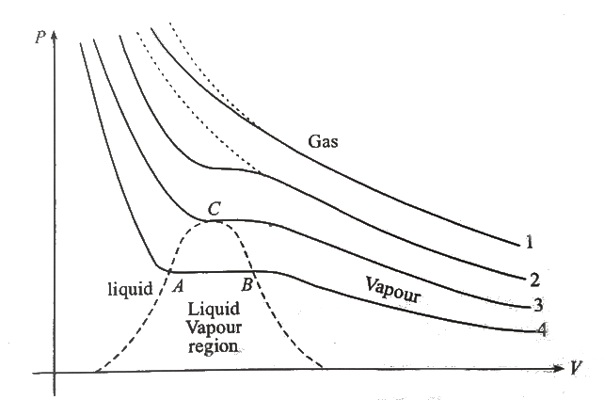

In figure curve-4 represents the situation when liquefaction occurs. At low pressure on curve-4, the substance is a gas and occupies large volume. As the pressure is increased, the volume decreases till point B. Beyond point B, the volume decreases without change in pressure. In this region the gas is gradually changing to liquid upto point A. At point A gas is completely liquefied. Further if we increase the pressure, volume changes slightly as liquids are almost incompressible so here curve is very steep. The region, where gas and liquid phase exist together in equilibrium.

If we carefully look on curve-3, we can see that at point C, curve is almost horizontal and it happens only at this point. This point C is called **critical point** and the gas temperature of curve- 3 is called **critical temperature** of the gas.

Critical temperature of a gas is defined as - "A gas will change to liquid phase if its temperature is less then critical temperature if sufficient pressure is applied on the gas". Above critical temperature, no matters whatever be the amount of pressure applied, the gas

can not be liquefied. As pressure is increased, gas becomes denser and denser and acquires the properties resembling to a liquid but does not condense.

A distinction is made between "gas" and "vapour", students should keep in mind that a substance below its critical temperature in gaseous state is called "vapour" (which can be liquefied on applying sufficient pressure on it) and a substance above its critical temperature in gaseous state is called "gas" (which can not be liquefied).

**Pressure of Air**

a Torricellian tube, the principle of today's barometer. If a glass tube, closed at one end, is completely filled with mercury and then inverted into a bowl of mercury, thecolumn of mercury in the tube drops until it reaches a height of about 76 cm above the lower surface

This is how barometer works and the height of mercury column in the tube gives the atmospheric pressure of air.   
If cross- sectional area of tube is A then the weight of mercury column is

W = hArhog

Thus pressure at its bottom is given as

p = W/A = hrhog

In general the height of mercury column in open atmosphere in standard conditions is about 76 cm, thus atmospheric pressure of air is given as

p = hrhog

= (0.76)(13.6 * 10 ^ 3)(9.81) W / (m ^ 2)

P_{air} =1.01*10^ 5 Pa = 1atm

This pressure is atmospheric pressure. An atmosphere (1atm) is a unit of pressure equal to the pressure of the earth's atmosphere at sea level.

Maxwell developed a relation to find atmospheric pressure as a function of height from ground level (more precisely sea level). The relation is named **Barometric Relation.** We first derive the relation mathematically (in the book) and than we'll discuss some uses and applications of this relation.

Final result

P = P_{0} e ^ (- (Mgh)/(RT))

Here P_{0} is the atmospheric pressure on ground-level or sea- level above equation gives the pressure of atmospheric air

at a height h above the earth surface and is called as Barometric formula. Using this we can also find the atmospheric air density at a height h above the ground level.

rho = rho_{0}e ^ (- (Mgh)/(RT))

(derivation in book)

rho_{0} = (P_{0}M)/(RT) can be taken as atmosphere air density at the ground level. Another form of Barometric formula can be written in terms of number of molecules per unit volume or the molecular density in atmosphere and can be given as

n = n_{0} e ^ (- (Mgh)/(RT))

Above equation are used with the assumption that the atmospheric temperature T and the acceleration due to gravity g remains constant within the limits of integration of expression in equation-(1). If in some region temperature gradient (dT/dh) exist then the above formula can be modified while integrating the expression in equation-(1).

**Distribution of Molecular Speeds**

- The molecules in a gas are assumed to be ramndom motion,. The graph shows how the speeds of molecules in a gas are distributed. This is known as Maxwell distribution of speeds.

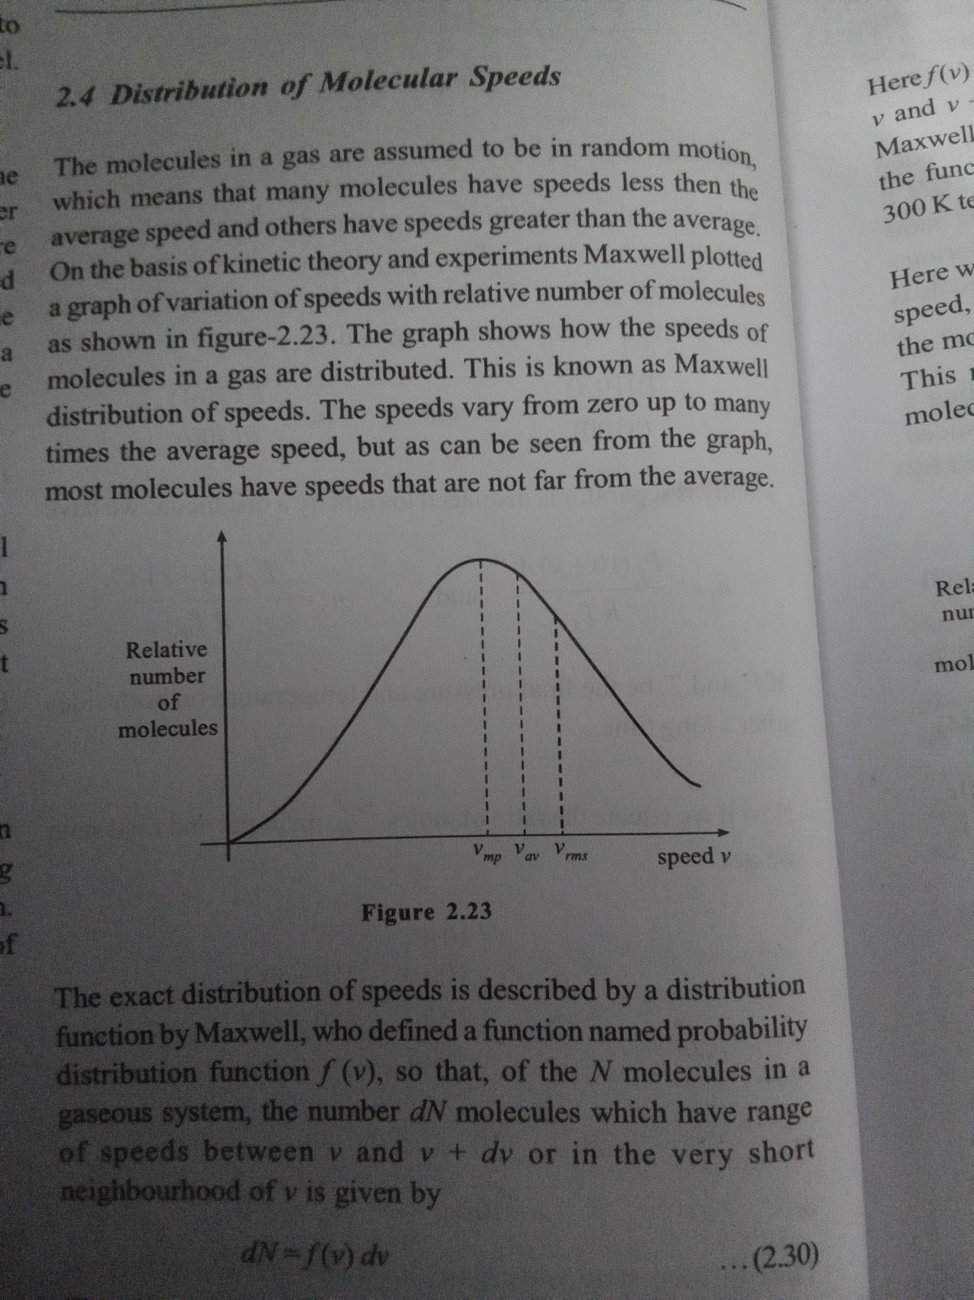

The exact distribution of speeds is described by a distribution function by Maxwell, who defined a function named probability distribution function f(v) so that, of the N molecules in a gaseous system, the number dN molecules which have range of speeds between v and v + dv or in the very short neighbourhood of v is given by

dN = f(v) dv

Thus f(v) is the number of molecules per unit range of speeds. As we have discussed that the speeds of molecules vary in a wide range from zero to infinity, from equation-(2.30), we can write for total number of molecules as

N = int_0^infty f(v)dv

The distribution function/(v) was obtained by statical analysis and found out as

f(v) = 4piNv^2[M/(2piRT)]^(3/2) e ^ (- (Mv^2)/(2RT))

Where R is universal gas constant and M is the molar mass, using equation-(2.32) we can write

f(v)dv = 4piNv^2[M/(2piRT)]^(3/2) e ^ (- (Mv^2)/(2RT))(dv)

Here f(v) dv is the number of molecules that have speeds between v and v + dv and this equation-(2.33) is called as analytical Maxwell Boltzmann distribution function. Figure-2.24(a) shows the function computed for oxygen, neon and helium gases at 300 K temperature.

Here we can observe that the peak of each curve represents the speed, the maximum number of molecules have and it is called the most probable speed for that gas at particular temperature. This most probable speed is exhibited by large number of molecules of a gas at a given temperature.

It can also be seen from figure-2.24(a) that more massive molecules have lower most probable speed. For a given gas, the most probable molecular speed becomes greater with increase in temperature as shown in figure-2.24(b). It can also be seen that more molecules have high speeds and fewer molecule have lower speeds throughout the range of speeds.

**Different Speeds For Molecules of a Gas**

(i) Average velocity of Gas Molecules

Initially we've discussed that all molecules of a gas in a container are in Brownian motion, thus due to randomness the directions of motion of different molecules are random and continuously changing due to repeated collisions randomly. If vec v_{1}, vec v_{2}..... vec v_{N} are the instantaneous velocity vectors of all N molecules of a gas, the average velocity vector of these N molecules can be written as

< vec v > = (vec v _{1} + vec v_{2} +......+ vec v_{N})/ N =0

It is obvious that as all vectors are randomly scattered in space thus their sum i.e. the numerator of expression in equation- (2.34) can be approximated to zero. Thus the average velocity vector of molecules in a gas is always taken as zero.

(**ii) Root-Mean-Square Velocity of Gas Molecules**

As the name implies this is the square root of mean of squares of velocities of all the molecules of a gas. Mean of squares can be simply written as

< v ^ 2 > =(( | vec v 1 |^ 2 +| vec v 2 |^ 2 +.......| vec v_{N} |^ 2 )/N )

And

v_{rms} = sqrt (<v^ 2 >)

=sqrt (( | vec v_{1} |^ 2 +| vec v_{2} |^ 2 +.....| vec v_{N} |^ 2 )/N )

Mathematically its value can be calculated by using the distribution function and taking the average of the square of the speed. Since f (v) dv is the number of molecules with speed v in the range dv, the mean square speed can be given as

< v ^ 2> = (int_0^infty v ^ 2 * f(v) dv )/N

Integrating the expression in equation-(2.36), we finally get

< v ^ 2 >= (3RT)/M

So that rms speed can be given as

v_{rms} = sqrt ((3RT)/ M)

In most of numeric calculation and analysis of kinetic theory we use rms velocity for gas molecules.

**(iii) Mean Speed of Gas Molecules**

We have discussed that due to randomness average velocity

vector of all the molecules of a gas comes out zero. But it is not same in case of mean or average speed. We obtain the mean speed by averaging the speed of the molecules. If can be simply defined as

<v> = (| vec v_{1} |+| vec v_{2} |+.....| vec v_{N} |)/ N

Using distribution mean speed as

<v> = (int_0^infty v*f(v) dv)/N

Integrating expression in equation

v_{mean} = sqrt((8RT)/(piM))

We can see on comparing equation

v_{mean} <v_{rms}

**(iv) Most Probable Speed of Gas Molecules**

As discussed this is the speed maximum number of molecules have, and this is the speed corresponding to which distribution function has maximum or peak value, It's value can be obtained by differentiating the distribution function f(v) and setting the derivative equal to zero. The final result obtained is

v_{mp} = sqrt ((2RT)/ M)

Comparing equation we can see

v_{mp} <v_{mean} <v_{rms}

**Pressure Exerted by a Gas**

When a gas is enclosed in a rigid container, we have discussed that the molecules of gas are in Brownian motion and randomly collide with each other and container walls. All these collisions are assumed to be perfectly elastic. Due to these continuous collisions of large number of gas molecules with container walls, a pressure is exerted on the walls. Now we calculate this pressure analytically. Consider N molecules of a gas enclosed in a

container as shown in figure-2.25. The length, width and height of container are l, w and h respectively along x, y and z direction. Out of several molecules, we consider one gas molecule of mass m' which is moving at an instant with a velocity v. This velocity has three components v_{x} v_{y} and v_{z} along x, y and z directions respectively.

Let us first consider the motion of this molecule in x direction only. If it is moving with a velocity v_{x} towards the wall EFGH. It collides with the wall elastically and rebonds with the same speed Now it is travelling towards the wall ABCD. During a v_{x} collision the momentum imparted to the wall by the molecule is

Deltap_{x} = 2 m' v_{x}

Now the molecule strikes the wall ABCD after travelling a distance / and strike again onto the wall EFGH with same speed v_{x} The average time between two collisions on same wall by the molecule is

Deltat = (2l)/v_{x}

Thus the frequency of collision by the molecule on same wall is

Deltan = 1/(Deltat) = v_{x}/(2l)

Thus the momentum imparted to the same wall by this molecule per second or the force exerted by this molecule in x-direction is

F_{x} = (Deltap_{x})/(Deltat) = (2 m' v_{x} ^ 2)/(2l) = (m' v_{x} ^ 2)/l

The pressure exerted by this molecule on wall ABCD is

P_{x} = F_{x}/(wh) = (m' v_{x} ^ 2)/(lwh) = (m' v_{x} ^ 2)/V

Similarly we can write the pressure exerted by the molecule on walls in y and z direction can be given as

P_{y} = (m' v_{y} ^ 2)/V

and P_{z} = (m' v_{z} ^ 2)/V

The average pressure by the molecule on container walls is

P = 1/3 (P_{x} + P_{y} + P_{z})

P= 1/3 (m')/v ( v_{x}^ 2 +v_{y} ^ 2 + v_{z} ^ 2 )

P = 1/3 (m')/v * v ^ 2

v ^ 2 = v_{x} ^ 2 + v_{y} ^ 2 + v_{z} ^ 2 is the root mean square (rms) velocity Where of a gas already discussed. Equation gives the average pressure on container walls due to motion of only one molecule. There are total N molecules of gas enclosed in the container. Thus total average pressure exerted by a gas on its container walls is

P = 1/3 (m')/v v ^ 2 * N

P = 1/3 m/v v ^ 2 [Where m = m' N is the total mass of gas]

P = 1/3 rho v ^ 2 --2

[Where rho = m/v is the density of gas]

Here we can also write

P = 2/3 (1/2 rho v ^ 2) = 2/3 e

Here e represents the average kinetic energy of gas per unit volume or average kinetic energy density of gas pressure of a gas in a container can also be derived in another way as shown in figure-2.26. Figure shows a container wall and the gas molecules in its neighbourhood. If total number of molecules in the container are N, then the molecular density n_{0} can be given as

n_{0} = N/V

We consider a cube C of unit volume 1 m³ near the wall shown. Total number of molecules in this cube are n_{0} (molecular density) and each molecule is assumed to be moving in a random direction with the rms speed v. Due to randomness it can be assumed that toward every face of the cube n/6 molecules are moving with this speed. Thus number of collisions with a container wall per second per square meter of its surface can be written as

N_{c} = n_{0}/6 v

this gives the number of collision per unit area of container wall in contact with a gas. As collisions are elastic, the momentum transferred to wall in each collision by a molecule is

∆p = 2 m' v

[If m' is the mass of each molecule]

Thus momentum transferred to a container wall per second per unit of its surface area or average pressure can be given as

P = (n_{0}v)/6* 2 m' v = 1/3 rho v ^ 2 [As no m' = p density of gas]

Thus we can see that equation above is identical with equation- (2). Equation-(2) was derived for a box shaped container but in derivation of above equation we haven't taken any specific shape of container. Thus, this relation of average pressure always remains same irrespective of the shape of container.

**Kinetic Energy of Gas Molecules**

We've discussed that all gas molecules in a container are in continuous random motion repeatedly colliding with neighbouring molecules and container walls elastically. As all collisions are considered to be perfectly elastic we can assume that the total kinetic energy of all the gas molecules remains constant and all molecules are assumed to be always moving with their rms velocity. In this situation kinetic energy of a gas molecule of mass m' can be given as

E_{K} = 1/2 m' v_{rms} ^ 2

E_{K} = 1/2 m' ((3RT)/M)

By definition, the molecular mass of a gas molecule can be given as

M=m’ N_{Av} [N_{Av} ^ - Avogadro Number]comparing

E_{K} = 1/2 m' ( 3RT) /(m’N_{Av} )= 3 /2 R/ N_{Av} T= 3 /2 kT

k= R /N_{A} =1.38*10^ -23 Joule/molecule, k is a universal constant called **boltzmann** **constant**. This equation gives the kinetic energy of a moving gas molecule in a gas at absolute temperature T. If we find the total kinetic energy of all the molecules of a gas, it is given as

E_{T} = 3/2 kT*N

[If N are the total no, of gas molecules in a container]

If moles of gas are there in a container, we have

N= n* N_{Av}

E_{T} = 3/2 ( R/ N_{Av} )T* n* N_{Av}

E_{T} = 3/2 nRT A

As we've discussed that total energy of a gas is the sum of kinetic energy of all of its molecules. Equation above thus gives the total energy of a gas in its molecular motion or the

expression in equation gives the total translational energy of all the gas molecules at absolute temperature T.

**Microscopic Interpretation of Temperature**

Thus in terms of average kinetic energy of a gas molecule E_{r} the temperature can be given by equation

T = 2/3 E_{T}/k

Details in book

Thus the average translational kinetic energy of gas molecules in an ideal gas depends only on the temperature, not on the pressure or type of gas. Thus equation-(2.58) shows that temperature is a measure of kinetic energies of molecules or temperature is a large-scale manifestation of motion at the molecular level of gases, liquids and solids.

**Degrees of Freedom and Equipartition of Energy**

In previous section we've derived a relation among temperature and average translational kinetic energy of a gas molecule as

E_{T} = 1/2 m' v_{rms} ^ 2 = 3 /2 kT

Initially we have discussed that if a molecule has v_{x}, v_{y} and v_{z} average velocity components in three dimensional coordinate system,

Detailed dunderstanding check out the book

**Internal Energy of a Gas**

Law of equipartition of energy states that the total energy of a gas molecule is equally divided among all of its degrees of freedom or the number of ways in which the molecule can contribute to its mechanical energy, and energy in each contribution type is 1/2 * kT

Derivation in book

Final result

U = f/2 nRT [As kN_{AV} =R]

The expression in equation above gives the sum of total kinetic energies of all types of motion of all the molecules of a gas, called as total internal energy of a gas. Our initial assumption for an ideal gas was, its molecules do not interact thus no potential energy exist for gas molecules thus energy given by equation above is the net amount of energy a gas can contain i.e. the internal energy of gas and it depends only on absolute temperature of the gas.

**Degrees of Freedom and Internal Energy For Different Types of Gases**

**Monoatomic Gases**

The molecule of a monoatomic gas is just a single atom hence has three translational degrees of freedom .Thus total internal energy of n moles of a monoatomic gas at a temperature T is given as

U=f/2nRT=3/2nRT

**Diatomic Gases**

The molecule of a diatomic gas consists of two atoms connected by a bond or interatomic forces between the two atoms. it has three translational degrees of freedom and 2 rotational .Thus in general, a diatomic gas molecule has five degrees of freedom.

(Detailed in book)

Thus total mechanical energy or internal energy of an ideal diatomic gas at a temperature T is given as

U = f/2 nRT

At low temperatures f = 5 thus

U = 5/2 nRT

At very high temperatures f = 7 thus

U = 7/2 nRT

**Polyatomic Gases**

A polyatomic gas molecule should also have three translational degrees of freedom and the number of rotational degrees of freedom depending on the geometry of the molecule. Number of vibrational degrees of freedom in complex polyatomic molecules varies in different ways. There is no simple theoretical way to calculate the exact number of active vibrational degrees of freedom in a polyatomic molecule.

Thus the total internal energy of n moles of a polyatomic gas at a temperature T is given as For a linear molecule

U = f/2 * nRT = ((5 + x)/2) * nRT

Where x are the number of vibrational degrees of freedoms

For a non linear molecule which has x number of vibrational degrees of freedom

U = f/2 * nRT = ((6 + x)/2) * nRT

**Equivalent Degrees of Freedom For a Gaseous Mixture**

We know if two substances at same temperature are connected or mixed, they do not exchange any thermal energy and the temperature of mixture remains same.

F_{eq} = (f_{1} n_{1} +f_{2} n_{2} +…. F_{N} n_{N})/( n_{1} +n_{2} +…. n_{N})

**Mixing of Gases at Constant Volume**

When some gases at different temperature are mixed at constant volume in a thermally insulated vessel, the total internal energy of all the gases remains constant.

T_{f} =( f_{1} n_{1}T_{1} + f_{2} n_{2}T_{2} +......+ f_{N} n_{N} T_{N})/(f_{1} n_{1} +f_{2} n_{2} +… f_{N} n_{N})

Equation can be used to find final temperture of the gaseous mixture

**Path of Molecules and Mean Free Path**

If we find the mean speed of a molecules of air at room temperature 25°C, we get v av = sqrt 8RT pi M = sqrt 8*8.314*298 3.14*29*10^ -3 = 466.54m / s

This is mean free path of the molecules, denoted by λ. As the name implies it is the average distance traversed by a molecule between two successive collisions. We expect lambda to vary inversely with the molecular density, the number of molecules per unit volume. The larger the molecular density is, the more collisions there should be in the dense gas and the smaller the mean free path. We also expect a to vary inversely with the size of molecules. If the molecules were point sized, they would never collide and the mean free path would be infinite. Thus the larger the molecules are, the smaller the mean free path

The exact expression for mean free path is turned out to be

lambda = 1/(sqrt(2) m d ^ 2 (N / V))

Here m is the mass of molecules and d is the molecular diameter. From gas law we have

PV = nRT or PV = NkT as R/N_{AV} = k if N are the total number of molecules in a gas, thus equation now become

lambda = (kT)/(sqrt(2) m d ^ 2 P)

**Vander Walls Gas Equation**

The ideal gas equation in equation-(2.7) can be used for different ideal gases but not for real gases due to the above reason. This ideal gas law can be modified for real gases and by introducing

some appropriate corrections, we can develop another equation of state for a real gas. This equation was developed by Dutch physicist J.D. Vander Walls. The equation is named vander walls gas equation after him and is given as

(P+ (an^2)/ V^2 ) (V-nb)=nRT

Here a and b are empirical constants, different for different gases. Roughly b is the volume of one mole of molecules, thus the total volume of molecules in n moles of a gas is then nb, and the total volume available for the molecules to move around in the gas is (V-n b). The constant a depends on the attractive intermolecular forces, which reduces the pressure of gas for given values of n, V and T' by pulling the molecules together as they push the walls of container during collisions. The decrease in pressure is proportional to the number of molecules per unit volume in a layer near the wall which are colliding and exerting pressure on walls and is also proportional to the number per unit volume in the next layer beyond the wall which are attracting the first layer molecules. Hence the decrease in pressure due to intermolecular forces is proportional to n^2/V^2.

When a gas is at very low pressure, (n/V) for the gas is very small or we can say that the gas is dilute, the separation between the gas molecules is large, the correlations in the vander walls equation become insignificant and equation reduces to ideal gas equation. Some times at very high temperature when kinetic energy of gas molecules is very high, the effect of molecular interaction is negligible. Thus we can say that at very low pressure or at very high temperature real gases may behave like ideal gases.